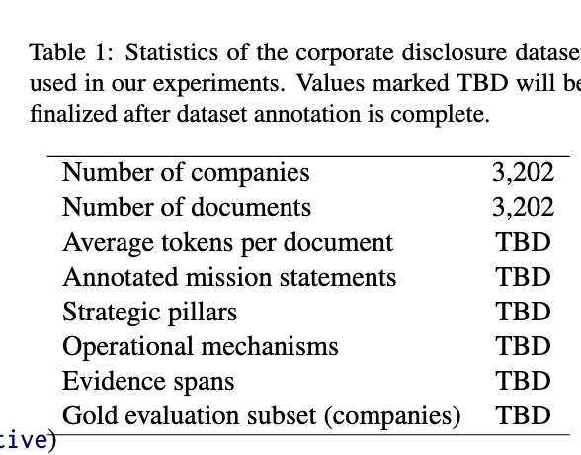

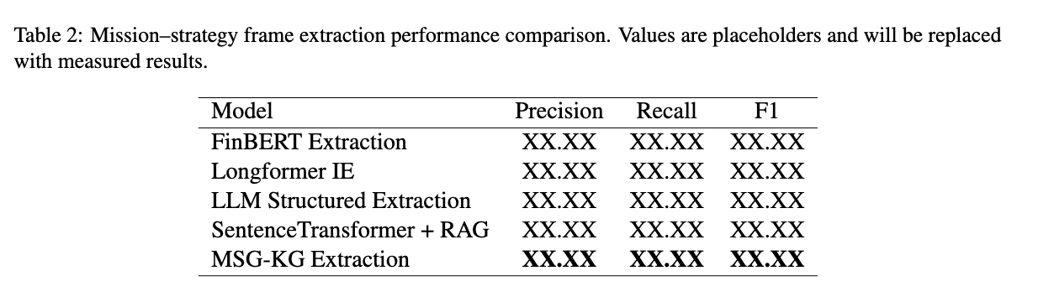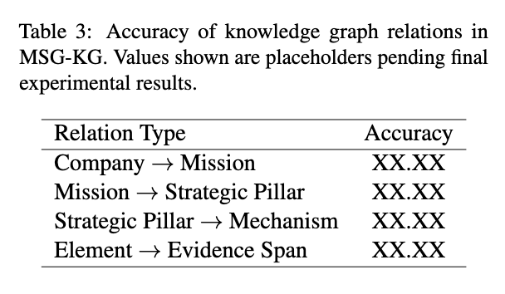
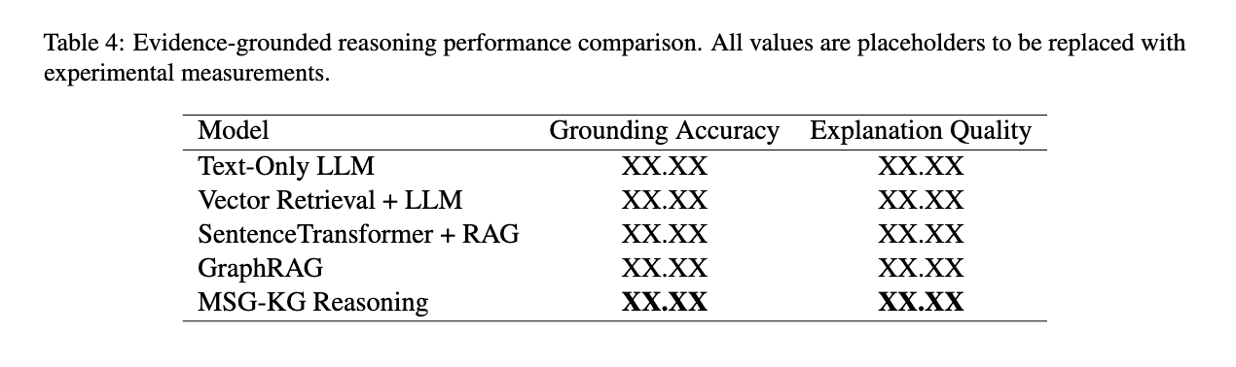
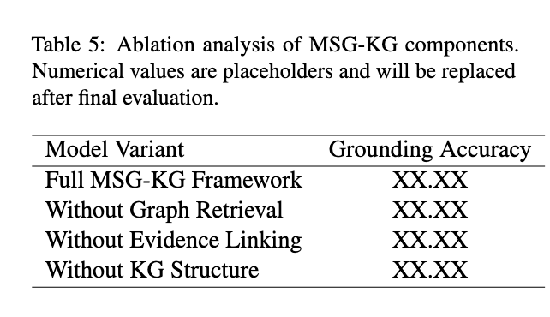
Below is a revised version with URLs included, written in a formal EMNLP-style tone and suitable for your Dataset / Annotation Protocol section. I also included citations and dataset links, which reviewers often appreciate for transparency.

Use of Existing Annotated Datasets
Because large-scale annotated datasets of mission–strategy structures extracted from corporate disclosures do not currently exist, we leverage existing mission-statement datasets as source-domain supervision and transfer this knowledge to the target domain of SEC 10-K filings.

Source-domain datasets
We utilize publicly available collections of mission statements compiled from organizational websites, including datasets available from:
- Kaggle Mission Statements dataset
https://www.kaggle.com/datasets/shivamb/mission-statements-what-makes-them-effective
- OpenDataBay Mission Statement dataset
https://www.opendatabay.com/data/financial/312eb2ad-e265-4443-9d01-e4c55408763d
- Corporate mission and vision research corpora analyzed in prior management research
https://journals.klalliance.org/index.php/JABR/article/view/60
These datasets contain curated mission statements collected from corporate and organizational websites and therefore provide supervised examples for mission-statement detection models.

Domain transfer to corporate disclosures
The primary corpus used in this study consists of corporate disclosures obtained from the SEC EDGAR system, which provides access to publicly available corporate filings such as 10-K annual reports:
- SEC EDGAR Corporate Filings
https://www.sec.gov/edgar
Because mission expressions in corporate filings often differ linguistically from mission statements on organizational websites, we apply domain transfer learning to adapt models trained on website-based mission datasets to the financial disclosure domain.
The training pipeline follows three stages:
Mission statement datasets (websites)
↓
Supervised training
↓
Mission detection model
↓
Application to 10-K filings
This process enables the model to identify candidate mission statements within long financial disclosures.

Zero-shot and few-shot learning with LLMs
In addition to transfer learning, we employ zero-shot and few-shot classification using large language models (LLMs) to identify mission-related passages in corporate filings.
Example prompt:
Task:
Identify whether the following passage expresses
a corporate mission statement.

Text:
"Our mission is to empower every person and every
organization on the planet to achieve more."

Answer:
Mission statement / Not mission statement
LLMs are capable of recognizing mission-style statements even when explicit phrases such as “our mission is” are absent.

Hybrid extraction pipeline
To improve robustness, the final system combines three stages:
- Pretraining using mission datasets
Models are trained using existing mission-statement corpora.
- Domain transfer to 10-K filings
The trained model identifies candidate mission passages in corporate disclosures.
- LLM refinement and structured extraction
Large language models refine candidate passages and extract structured mission–strategy elements.
Mission datasets
↓
Supervised training
↓
10-K filings
↓
Candidate mission passages
↓
LLM verification
↓
Structured mission–strategy elements

Gold evaluation subset
To evaluate the system, we construct a human-verified gold subset from the extracted mission candidates.
Example experimental configuration:
Dataset | Size | Purpose
Mission statement datasets | external corpora | supervised training
10-K filings | 3,202 companies | target corpus
LLM annotations | full corpus | weak supervision
Human-verified subset | ~100 companies | evaluation

Key advantage
This hybrid approach allows us to leverage existing annotated mission-statement datasets while adapting models to the financial disclosure domain. It also enables the creation of a new mission–strategy dataset derived from SEC corporate filings, which may serve as a useful resource for future research on strategic analysis of corporate narratives.

